North East University Bangladesh

Department of Computer Science and Engineering



ALUMNI ASSOCIATION NEUB

**By**

Bilasi Debnath 160103020029

Ishrat Jahan Tisha 170103020102

Department of Computer Science and Engineering

**Supervised By**

Buddha Chandra Banik

Lecturer

Department of Computer Science and Engineering

Date: 16th January, 2020

**Recommendation Letter from Project Supervisor**

The student’s*,* **Ishrat Jahan Tisha, Bilasi Debnath**whose project entitled**“ALUMNI ASSOCIATION NEUB”,** is under my supervision and I agree to submit for examination.

Signature of the Supervisor ：

Buddha Chandra Banik

Lecturer

Department of Computer Science and Engineering North East University Bangladesh

# Abstract

A common concern in institutions of higher education is to keep its former students involved with academic activities.

It is an agreement that one of the most valuable assets of universities is their alumni, given that their accomplishments ensure more exposure for the university. In recent years, universities have encouraged a movement toward the establishment of alumni associations, as they provide networking opportunities and contact between the university and the alumni or among the alumni.

An association that seeks membership and participation of its alumni should invest in the development of an attractive way.

In this sense, the project is aimed at analyzing a new system for alumni association mainly designed for North East University Bangladesh which is easy, fast, and efficient communication system. The system is a web based application that can be accessed throughout the World which manages information about the university and the students, gone together with technology.

**TABLE OF CONTENTS**

**Chapter 1**

1.1 Introduction 7

1.2 Background Information 7

1.3 Goal of These Project 8

1.4 Working Progress 8

**Chapter 2**

**Background Study**

2.1 Current Situation 8

**Chapter 3**

**Feasibility Study**

3.1 User and Admin Feasibility 8

3.2 Developer’s Site Feasibility 9

**Chapter 4**

**Requirement Analysis**

4.1 Requirements of the system 10

4.1.1 Functional Requirements 10

4.1.2 Non-Functional Requirements 10

4.2 Functionalities 11

**Chapter 5**

**ERD & Database Design**

ERD Diagram 12

Database Design 13

**Chapter 6**

**Graphical User Interface**

6.1 Home 14

6.2 Login 15

6.3 Registration Form 16

6.4 About us 16

6.5 Gallery 17

6.6 Committee 17

6.7 Event Page 18

6.8 Contact Page 18

6.9 Career Page 19

6.10 Admin Panel Dashboard Page 19

6.11 Admin Panel Register page 20

6.12 Admin Panel Event Page 20

6.13 Admin Panel Member List 20

6.14 Admin Panel Committee List 21

6.15 Admin Panel Contact Informations 21

6.16 Admin Panel Career Create Post 21

**Chapter 7**

Tools used 22

**Reference** 23

**ACKNOWLEDGEMENT**

# 

Thank you Allah,

Secondly we wish to extend our sincere appreciation to Buddha Chandra Banik sir his continuous supervision, guidance, advice and constructive ideas throughout our work and making this partial project to be successful. We hope his cooperation will proceed till the end of the project.

At the last, but not least, even if it is unusual, special gratitude for the group member participates with a great role with each other. Without the contribution of the group, our work would not be successful.

# Chapter 1

## 1.1 Introduction

The greatest asset any Institution can have is the Alumni system. Alumni are the people who represent the Institution in the real world. Alumni website is created for the students that have graduated from the Institution. This is a web based application that allows former students to take advantage of the benefits and services that a Institution offers after graduation. The alumni network is becoming important in the development of the institution because of their vast potential that benefits both the Institution and the students. There are many benefits for being an alumni member of a college or Institution, some of these benefits are: keeping a person inform on the events that are organized by the Institution, and when some important events will be holding in the Institution. Another benefit is that information concerning a former student can easily be received and other members of the alumni community can be located without much stress. The student and alumni can communicate each other.

## 1.2 Background Information

Alumni are one of the most important assets to any university. They are the people who represent the university in the real world. Many alumni network initially started from regional groups of alumni brought together for university fundraising activities. Later, these networks slowly gained added importance in the development of the university because of their enormous outreach potential that benefits the university and helps other societies in their career paths.

Alumni association has been in existence for decades and they are constantly changing with time. There have been very big changes in the recent years with the development of the internet and social networking that forces the alumni system to undergo huge changes. Therefore, it is really important for universities to focus on the alumni networks and find ways to enhance their growth and development.

The system called “ALUMNI ASSOCIATION NEUB” proposed in this ideas offers an inter mix of traditional alumni systems and social networking sites. The brief study on both systems is undertaken and important features of these systems are incorporated into the new proposed system.

Why Social networking? This can be described as the act of social relationships for the purpose of common needs, interests or goals. Networking has been taking place all over the world since the existence of humans. Nowadays networking has become easy because of the development of technology. People can interact with one another and share their ideas, discuss their personal and professional lives without even moving from their desks. The existing systems are usually developed to facilitate networking between the alumni and their respective universities, but most of these current systems are not being used by the majority of the alumni.

**1.3 Goal Of These Project**

The main goal of the project is to provide a user friendly website so that the information about event and program, career, job corner, payment, user details, committee list details are properly handle with the website.

**1.4 WORKING PROGRESS:**

1. Requirement analysis complete successfully.
2. Entity relationship diagram fully completed.
3. MySQL Database implementation completed.
4. User interface design fully completed include admin panel.
5. 60% backend completed include login, signup etc.

**Chapter 2**

**BACKGROUND STUDY**

**Overview**

We have analyzed some of the websites for our background study such like various Alumni Association CSE, Alumni Association etc. to get idea for designing our interface, E-R diagram, database designing and user functionalities.

**2.1 Current Situation**

These type of website is currently used by many universities but in our university their have no such website.

**Chapter 3**

**FEASIBILITY STUDY**

**The feasibility study is divided into two sites:**

1. User and admin feasibility
2. Developer site feasibility
   1. **User and admin feasibility**

* **Technical Feasibility**

To use the system users need a personal computer with the following hardware like – Processor: Intel Dual Core (or above)

RAM: 512 MB (min)

Hard Disk: 30 GB (or above), Or A mobile phone with latest browser.

* **Financial Feasibility**

For this system some amounts will be spend like –Internet Bills

The system will follow freeware software standards. No costs will be charge from the potential users.

* **Resource Feasibility**

Resource that is required for the system –Laptop / Desktop / Mobile Phone

Active Internet Connections.

* **Risk Feasibility**

Users will get all facilities which are needed for this system.

They will get all the requirements to use this system.

**3.2 Developer’s Site Feasibility**

* **Technical Feasibility**

The system will be established by HTML, CSS, Bootstrap, JavaScript, and JQuery in frontend and PHP, MySQL Server in the backend.

The hardware needs-

* Processor : Intel Dual core(or Above)
* RAM:2GB
* Hard Disk : 30 GB (or Above)

So, the project is technically feasible.

* **Financial Feasibility**

This assessment typically involves a cost analysis.

For this project some amount will spent like-

* Internet bills.
* Arrange meetings with society members & teachers etc.

So, the project is financially feasible.

* **Resource Feasibility**

Resources that are needed like-

* Laptop/Desktop
* Hosting space
* **Risk feasibility**
* The tools which are needed to develop the project are all available and free source to use.
* The project is being a 8 month project. We have divided our work into several sections and hopefully we will complete the project in time and deliver.

**Chapter 4**

**REQUIREMENT ANALYSIS**

**We have done our Requirement Analysis part with the following steps:**

* Talked with teacher of department of CSE and alumnus for collect data.
* Interviewed with the developer of similar systems.
* Visited similar existing websites.
* Analyzed those data to find different types of requirements.

**4.1 Requirements of the system**

The requirements of the system divided into two types:

1. Functional Requirements

2. Non – Functional Requirements

* + 1. **Functional Requirements**

There are two types of functional requirement –

* Normal Functional Requirements
* Expected Functional Requirements
* **Normal Functional Requirements**
* The system should require information about its Users.
* Store the information's of Users in database.
* Store the information's of posts in database.
* A Super Admin will verify a new registered user.
* System should also require the functionalities like User registration, Profile, Update profile, create an event, search etc.
* **Expected Functional Requirements**
  + Mobile responsive.
    1. **Non-Functional Requirements**

**The system is able to perform the following characteristics-**

* **Usability:** The system can be operate from any kind of Operating System.
* **Reliability:** The system is available on the user needs, can work properly. Every registered user account will be verified by email & admin and also password protected.
* **Performance:** The system will be optimized and can perform better in any web browser.
* **User interface:** The user interface will be user friendly which is easy to use.
* **Storage Backup:** There will be a storage backup for the system so that the information of users and posts data’s can’t be loss.
  1. **FUNCTIONALITIES**

Based on our requirement, we decided some functionalities for different type of users. There are three types of authorized user, they are Committee members, members and Super Admin (The president of ALUMNI ASSOCIATION NEUB).

* **Committee Members:**

1. Can create an account.

2. Can add/remove members.

3. Can collect membership fee from alumnus.

4. Can manage events completely.

5. Can create job posts.

6. Can create career guidance posts.

* **Members:**

1. Can create an account.

2. Can manage events registration only.

3. Can create post in career.

4. Can create post in job corner.

5. Can comment under post

6. Can see job corner.

7. Can see events.

8. Can see committee members.

9. Can see other members.

* **Super Admin:**

1. Can view all users.

2. Verify registered users.

3. Can add/remove user.

4. Can add/remove alumnus..

5. Can collect membership fee from alumnus.

6. Can manage events completely.

7. Can create job posts.

8. Can create career posts.

# Chapter 5

# ERD & DATABASE DESIGN

**Overview**In this chapter we will discuss about our ERD and all database tables.

**ERD diagram**

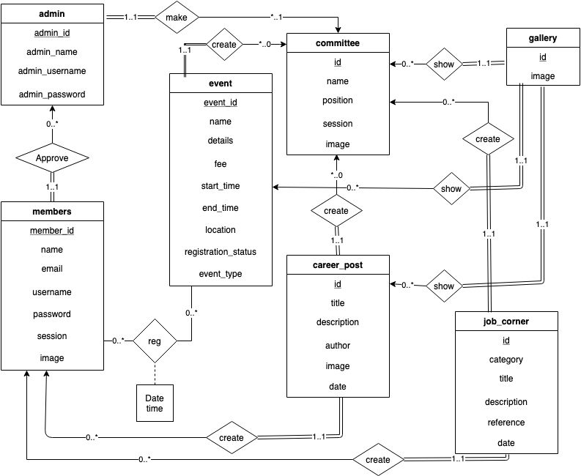

**Fig: ERD Diagram With UML Notations**

**All database tables:**

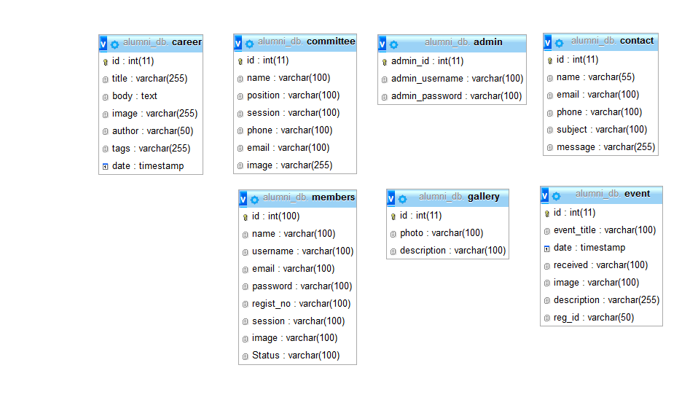

**Fig: All Database Table**

# Chapter 6 Graphical User Interface

**Overview**

In this chapter we will discuss about the User Interfaces of this websites.

**6.1 Home**

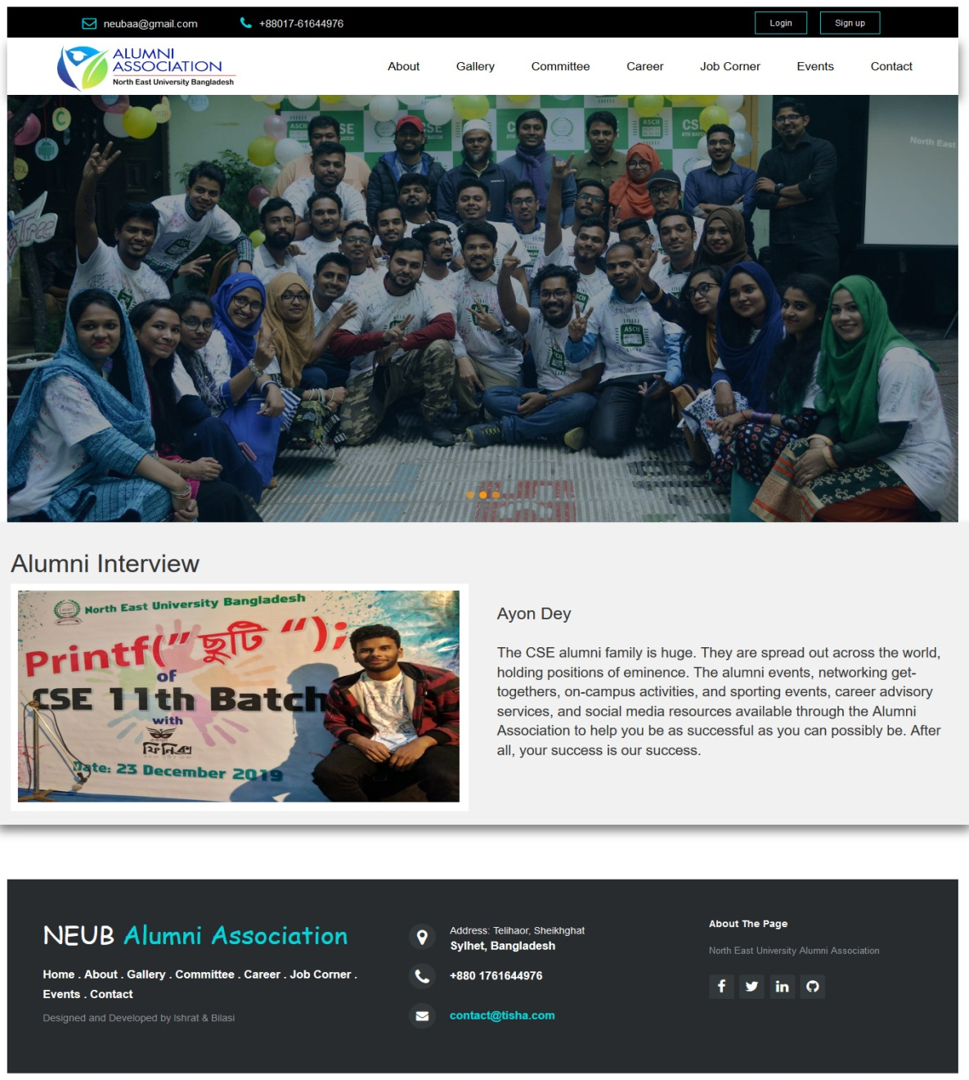

**Fig: Home Menu**

This is the home page menu bar that is the very first page where user can access all other pages to see the about, gallery, committee, career, job corner, contact us and others.

**6.2 Login (admin and users)**

**Admin login**

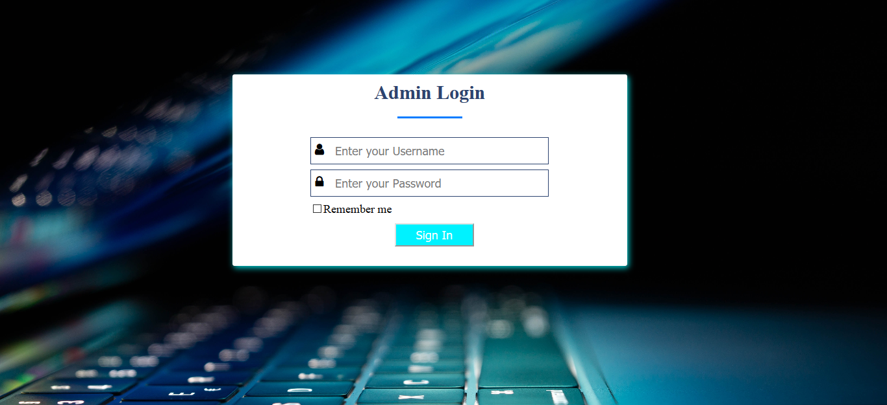

**Fig: Admin Login page**

In this page admin can login with their username and password.

**User login**

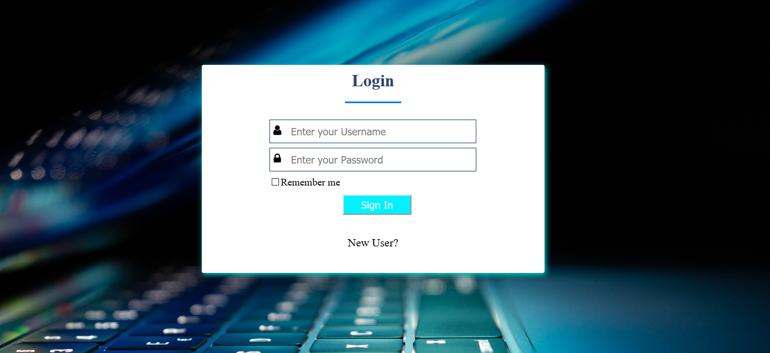

**Fig: Login page**

In this page members can login with their username and password.

**6.3 Registration form**

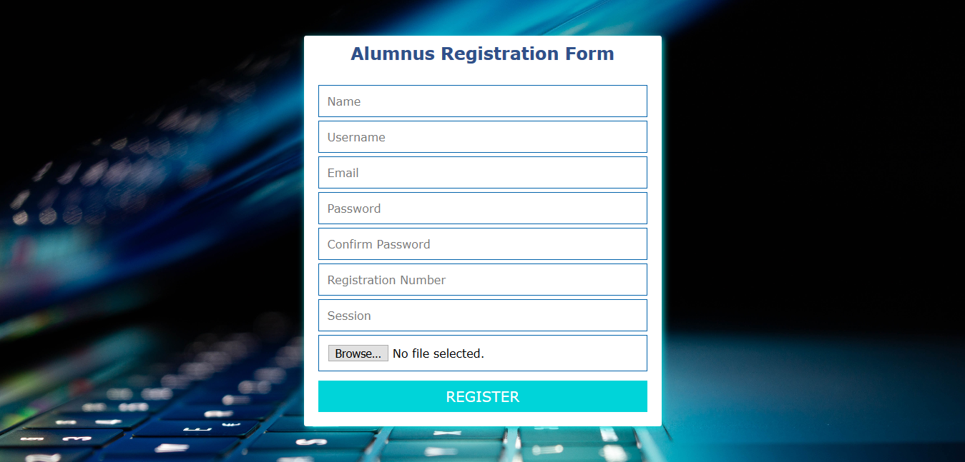

**Fig: registration form**

**6.4 About us**

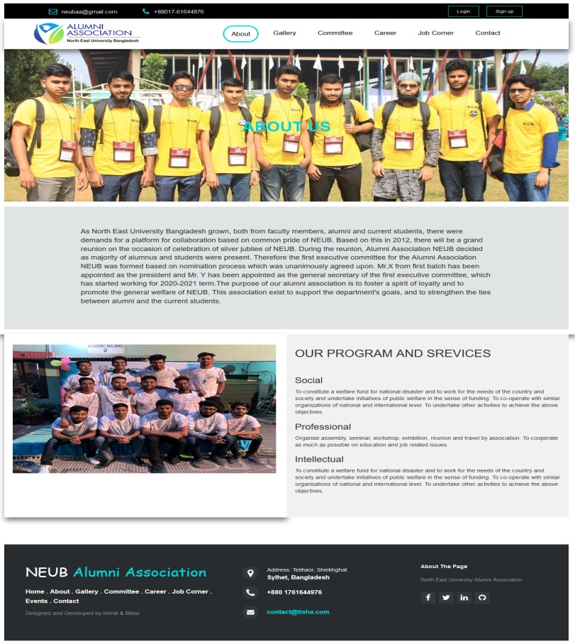

**Fig: About page**

In this page admin can organize a local or national debate with debaters.

**6.5 Gallery**

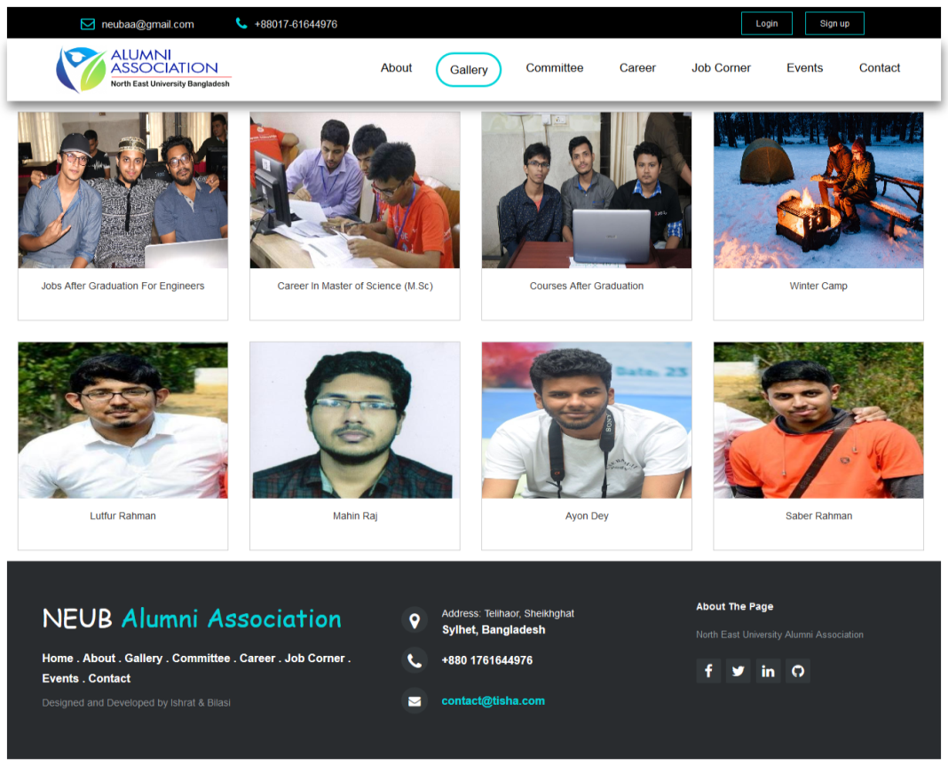

**Fig: Photo gallery**

**6.6 Committee List**

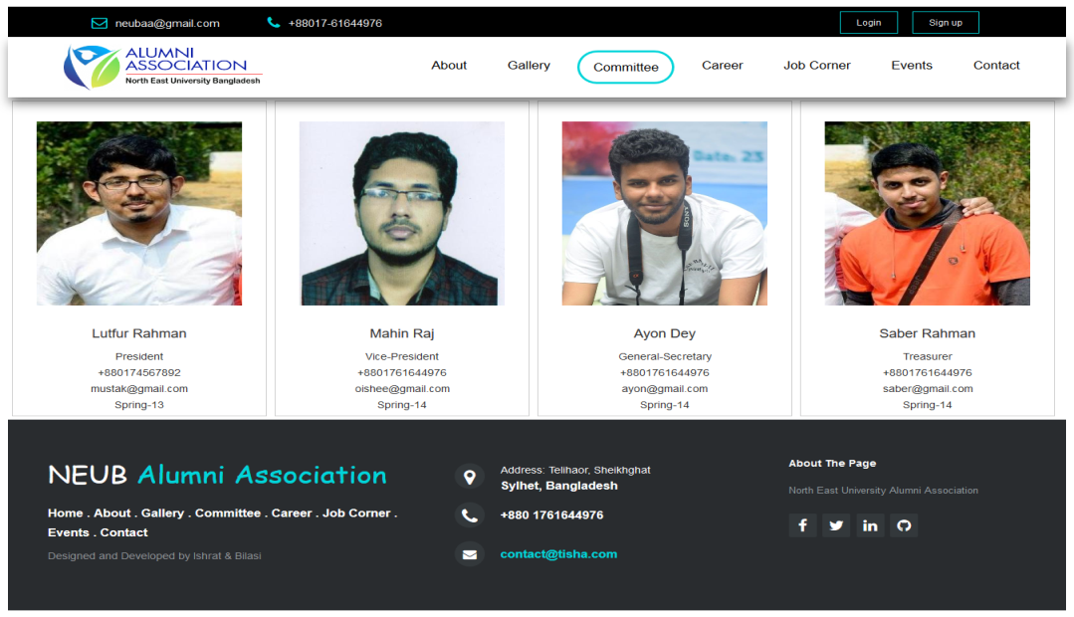

**Fig: Committee**

This page contains all committee members list.

**6.7 Event page**

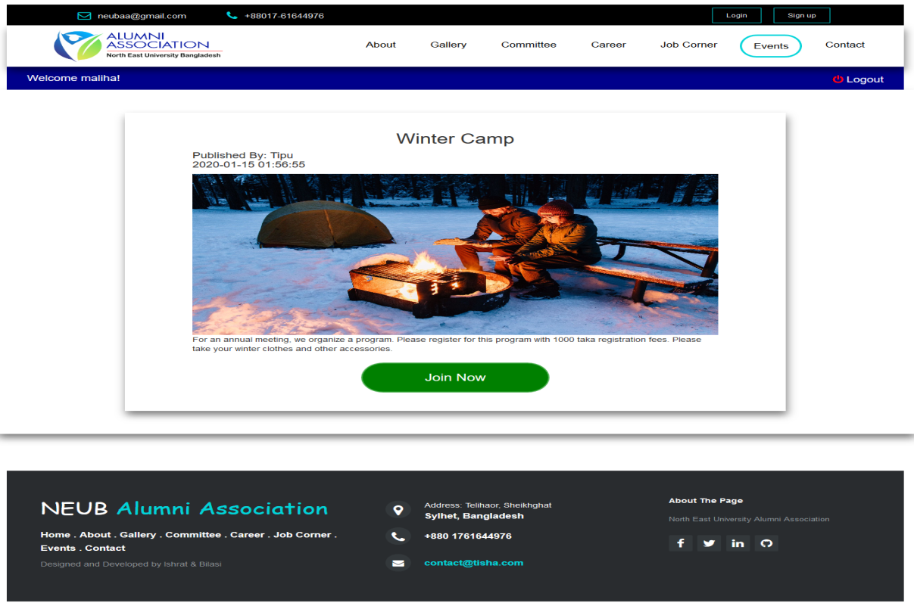

**Fig: Event and Programs**

**6.8 Contact page**

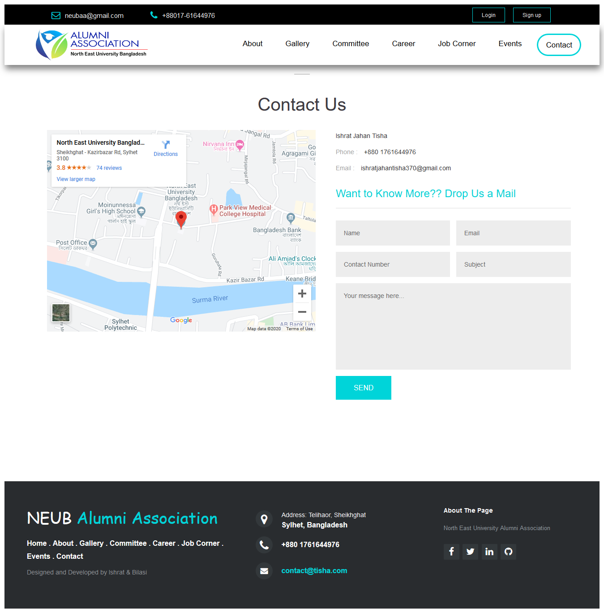

**Fig: contact page**

**6.9 Career page**

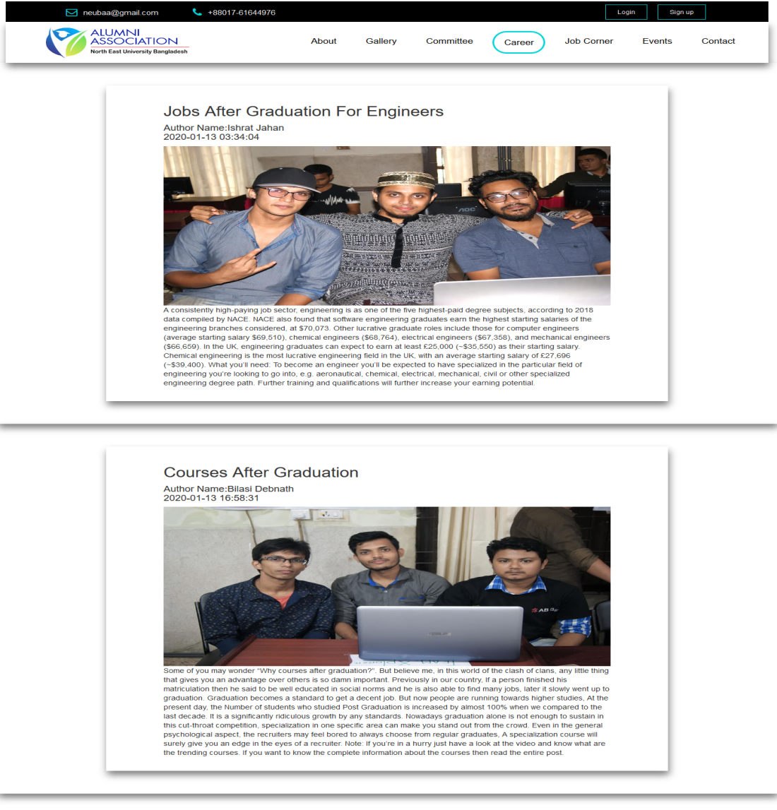

**Fig: Career page**

**6.10 Admin Dashboard page**

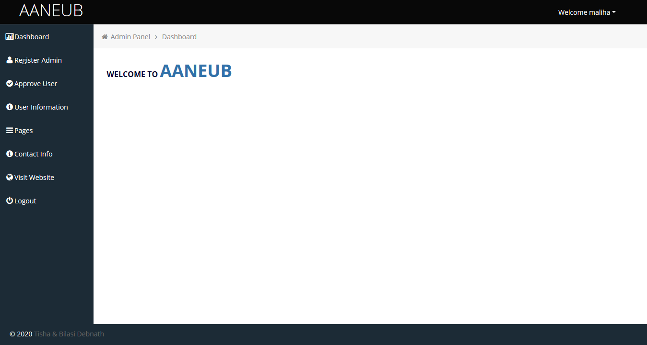

**Fig: admin dashboard page**

**6.11 Admin register page**

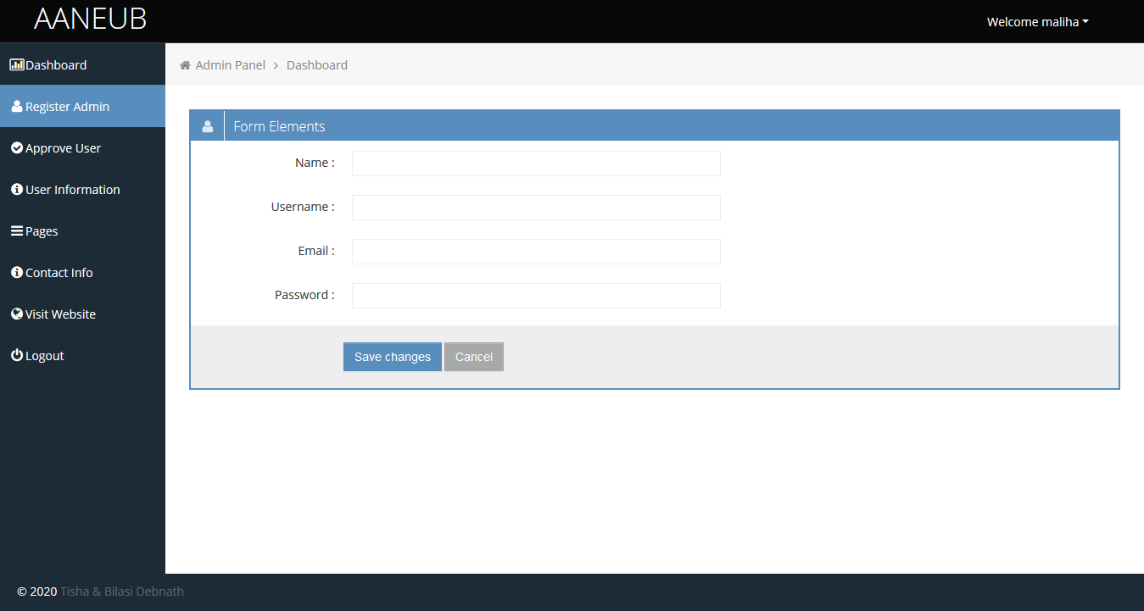

**Fig: Admin register page**

**6.12 Admin event page**

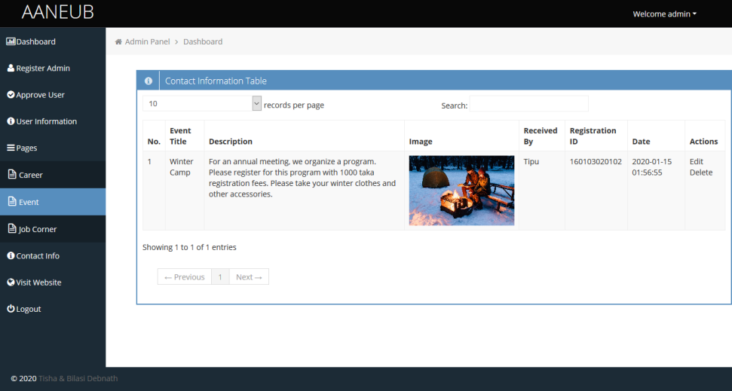

**Fig: Admin event page**

**6.13 Admin panel members list**

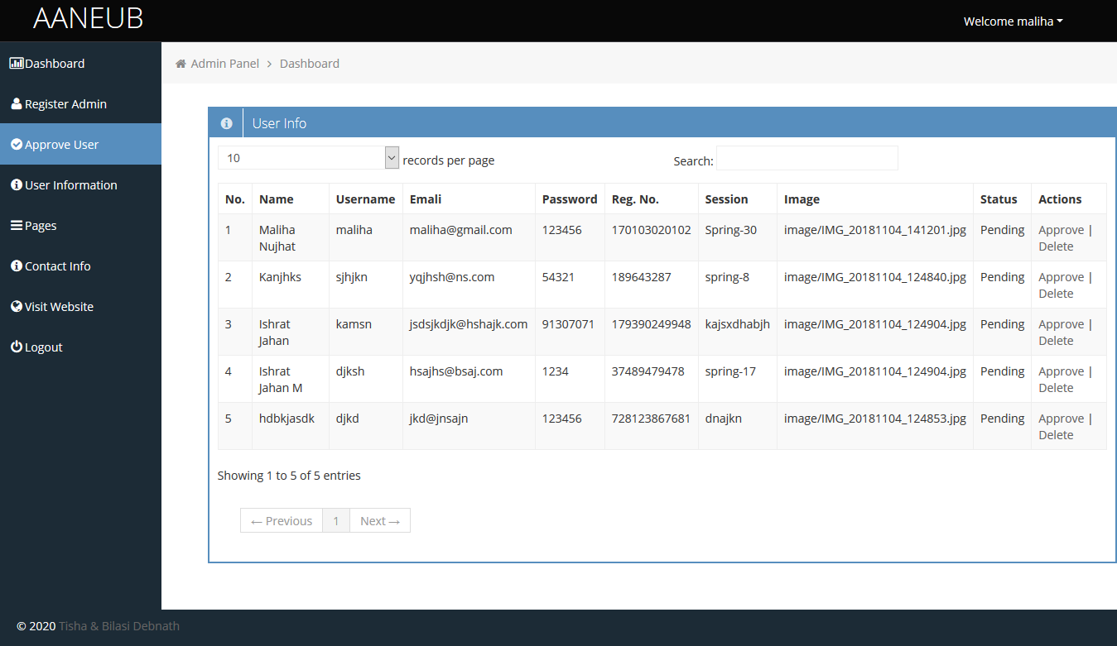

**Fig: Admin panel members list**

**6.14 Admin panel committee list**



**Fig: Admin panel committee list**

**6.15 Admin panel contact informations**

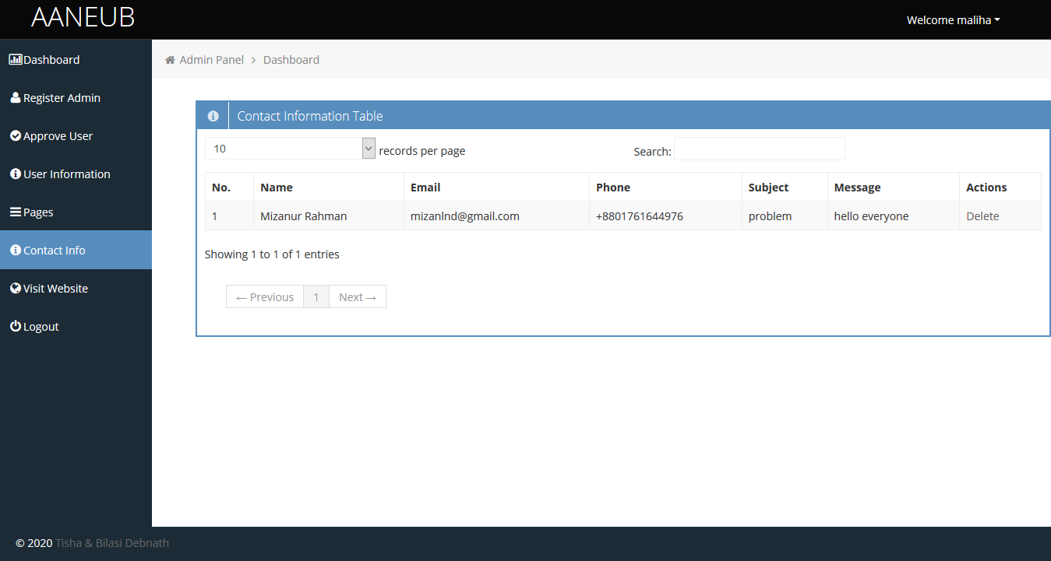

**Fig: Admin panel contact list**

**6.16 Admin panel career create post**

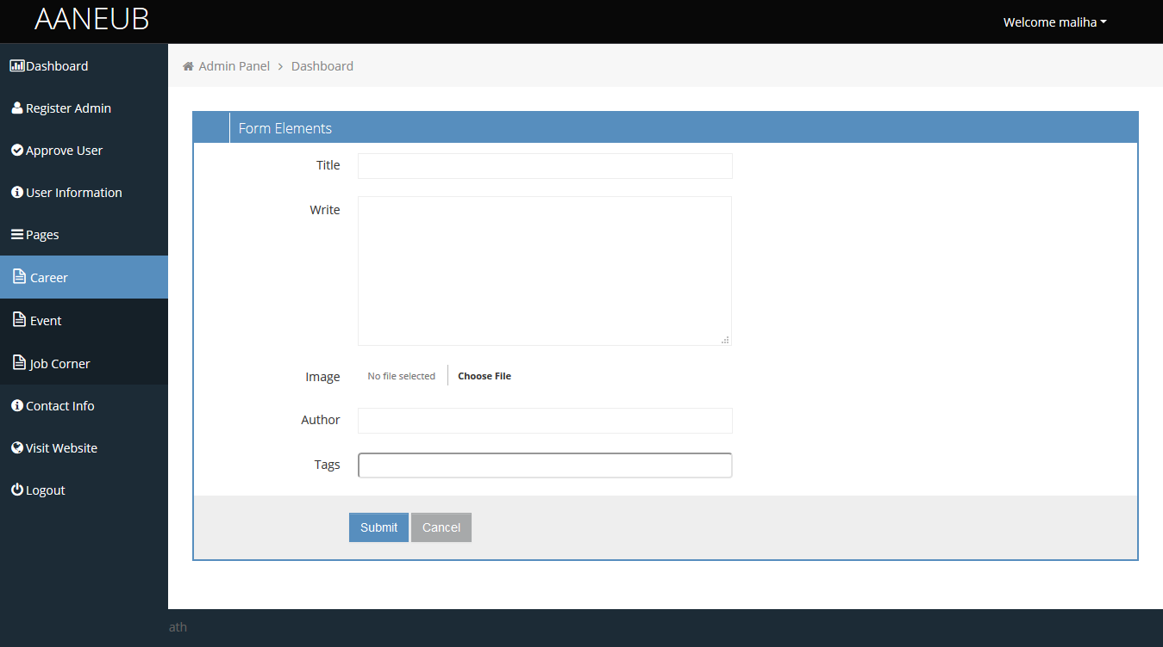

**Fig: Admin panel career create**

# Chapter 7

# TOOLS USED

**Overview**

In this chapter we will discuss about the tools used to develop the Website.

## Tools used

* + - **HTML, CSS**  
      Basically HTML and CSS are mostly used for designing part that is called front end designing. Here we used html and CSS for our font end designing part. Html used for coding of design and CSS we used for make the pages attractive and user friendly.
    - **W3CSS, BOOTSTRAP, JQuery, JavaScript**

We used their some classes for making an efficient, attractive and responsive website, as a result our website system response very faster than before which will be user friendly for our user.

* + - **PHP**

We will use PHP for our back end designing part that will be implemented through coding and will make an effective relationship between students and others.

### MySQL

MySQL is an open source relational database management system([RDBMS](https://searchsqlserver.techtarget.com/definition/relational-database-management-system)) based on Structured Query Language ([SQL](https://searchsqlserver.techtarget.com/definition/SQL)). We are using MySQL. We are using MySQL for designing the database of our website.

**References**

**Books:**

1. Web Engineering: The Discipline of Systematic Development of Web Applications, Editors: Gerti Kappel, Birgit Pröll, Siegfried Reich, Werner Retschitzegger(Kappel).

2. Database System Concepts by Silberschatz, Korth and Sudarshan.

**Website:**

[https://www.neub.edu.bd/](https://www.neub.edu.bd/%20)

<https://cseaasust.org/>

[https://duaa-bd.org/](https://duaa-bd.org/%20)

[https://www.draw.io/](https://www.draw.io/%20)

**Future Work Plan:**

1. Rest of 40% backend complete within next march-2020.

2. Test Project & if any change needed will do complete within april-2020.